

Taking a AR(1) model (Type of Dickey Filler Test)

🡪

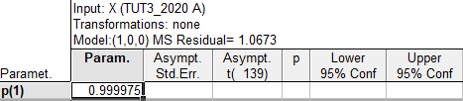

This the time series has a unit root and is non-stationary. Therefore we have to take the 1st difference to remove the unit root and make the time series stationary.



This time series is oscillating around some constant (appears to be 0). We will use a AR(1) again and fit it with the 1st difference time series to indicate if the time series is stationary.

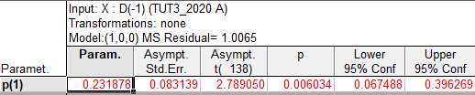

$${∆X}_{t}: φ_{1}=0.231878<1$$

This the time series does not have a unit root and is stationary.

b.

**Autocorrelation plot(ACF) of the 1st Difference model [D(-1)]:**



**Partial Autocorrelation(PACF) of the 1st Difference model [D(-1)]:**



**Potential Model – ARIMA(2,1,0):**

The ACF model is decaying in a sine-cosine fashion and the PACF is cutting of at lag 2 therefore the 1st potential model can be an ARIMA(2,1,0) model.

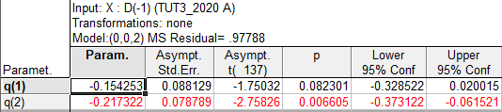

The above table indicates that only the second estimated parameter is significant due to the p-value < 0.05.

$$φ_{1}= -0.154253 p-value=0.082301$$

$$φ_{2}=-0.217322 p-value=0.006605$$

**Want to perform a Ljung Type Test to test for White Noise:**



$$Lag 12 :$$

$$Q-statistic =18.75$$

$$P-value = 0.0948$$

$$H_{0}: ρ_{k}=0→White Noise Residuals$$

$$H_{0}: ρ_{k}≠0→Non White Noise Residuals$$

$$P-value = 0.2360$$

**Interpretation:**

The p-value is larger than 0.05, thus it is not significant and we cannot reject the null hypothesis. This tells us the model has white noise residuals.

**Look the model with smallest Mean Squared Residual:**

$$MSR=0.97788$$

**Potential Model – ARIMA(1,1,1):**

The 2nd potential model is a ARIMA(1,1,1) , due to the ACF decreasing exponentially as well as the PACF.

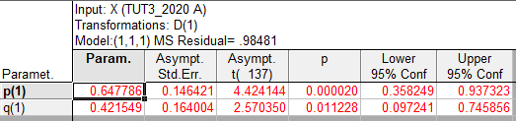

The above table indicates that all the estimated parameters are significant due to the p-value < 0.05.

$$φ_{1}= 0.647786 p-value=0.00002$$

$$θ_{1}=-0.421549 p-value=0.01128$$

**Ljung Box Pierce Test 🡪 Test for White Noise:**



$$H_{0}: ρ_{k}=0→White Noise Process$$

$$H_{0}: ρ_{k}≠0→Non White Noise Process$$

$$Q=15.15$$

$$P-value = 0.3334$$

**Interpretation:**

The p-value is larger than 0.05, so it is not significant and again we cannot reject the null hypothesis. Thus the model has white noise residuals.

**Consider the model with smallest Mean Squared Residual:**

$$MS=0.98481$$

**Conclusion:**

The ARIMA(2,1,0) has a smaller mean squared(MS) residual than the ARIMA(1,1,1) model, however the ARIMA(1,1,1) model’s parameters are all significant and its residuals are more white noise (higher Q value) than the ARIMA(2,1,0), so we rather continue with the ARIMA(1,1,1)

**Conditional (CL) Box Jenkins Estimating Procedure:**

**Want to perform a Ljung Type Test:**



$$\hat{φ_{1}}= 0.647786 p-value=0.00002$$

$$\hat{θ_{1}}=-0.421549 p-value=0.01128$$

**Interpretation:**

The p-value’s for all parameters are smaller than 0.05, indicating all parameters are statistically significant.

$$Conditional Estimation- MSR=0.98481$$

**Unconditional Box Jenkins Estimating Procedure:**

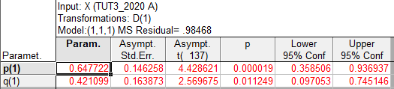



**Interpretation:**

The p-value is larger than 0.05 and therefore not significant. We cannot reject the null hypothesis. This the model has white noise residuals.

$$\hat{φ_{1}}= 0.647722 p-value=0.00002$$

$$\hat{θ_{1}}=-0.421099 p-value=0.011249$$

**Interpretation:**

The p-value’s for all parameters are smaller than 0.05, this all parameters are statistically significant.

$$Unconditional Estimation-MSR=0.98468$$

$Conditional Estimation- MSR=0.98481$

$$Unconditional Estimation-MSR=0.98468$$

The unconditional estimate procedure is the best procedure due to having the smallest MSR value when comparing it to the MSR of the conditional procedure. Therefore, we will choose the unconditional procedure.

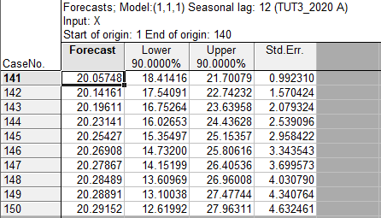



**Interpretation:**

The Actual Values fall in the limits of the Forecasted values.

|  |  |  |  |  |  |
| --- | --- | --- | --- | --- | --- |
| CaseNo. | Forecasts; Model:(1,1,1) Seasonal lag: 12 (TUT3_2020 A) Input: X Start of origin: 1 End of origin: 140 | | | | |
| Forecast | Actual | Lower | Upper | Resids |
| 141 | 20.05748 | 20.6234 | 18.41416 | 21.70079 | 0.320271 |
| 142 | 20.14161 | 22.27406 | 17.54091 | 22.74232 | 4.547336 |
| 143 | 20.19611 | 22.90014 | 16.75264 | 23.63958 | 7.311787 |
| 144 | 20.23141 | 23.12174 | 16.02653 | 24.43628 | 8.354024 |
| 145 | 20.25427 | 23.26957 | 15.35497 | 25.15357 | 9.092029 |
| 146 | 20.26908 | 24.26084 | 14.73200 | 25.80616 | 15.934147 |
| 147 | 20.27867 | 24.88724 | 14.15199 | 26.40536 | 21.238894 |
| 148 | 20.28489 | 25.35126 | 13.60969 | 26.96008 | 25.668149 |
| 149 | 20.28891 | 25.05053 | 13.10038 | 27.47744 | 22.673024 |
| 150 | 20.29152 | 26.35889 | 12.61992 | 27.96311 | 36.813018 |
|  |  |  |  | MSE = | 151.952680 |